**Consider the below two tables**:

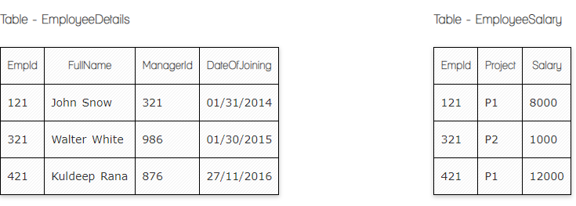

**Ques.1. Write a SQL query to fetch the count of employees working in project 'P1'.**

**Your Answer:**

Select count(EmpId) from EmployeeSalary

Where Project = “P1”

**Ques.2. Write a SQL query to fetch employee names having salary greater than or equal to 5000 and less than or equal 10000.**

**Your Answer:**

Select ed.FullName from EmployeeSalary es

Inner join EmployeeDetails ed On es.EmpId = ed.EmpId

Where Salary between 5000 and 10000

**Ques.3. Write a SQL query to fetch count of employees sorted by project's count in descending order.**

**Your Answer:**

Select count(EmpId), Project from EmployeeSalary

Group by Project

Order by count(EmpId)

**Ques.4. Write a SQL query to fetch all the Employees details from EmployeeDetails table who joined in Year 2016.**

**Your Answer:**

Select * from EmployeeDetails

Where DateOfJoining like ‘%2016’

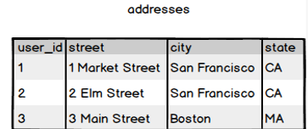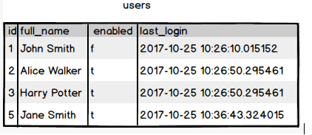

**Ques.5. Write a SQL query to fetch user full_name who is equal to user_id from Boston (find user_id value in sub_query)**

**Your Answer:**

Select full_name from users

Where id in (Select user_id from addresses

Where city = ‘Boston’)